* Assume the crank arm to be L=175mm with about a 250mm stroke.

Ignore non-axial force acted on the arm, only consider the compressive load.

* Calculation: Given the output of geartrain torque as T.

1. **The axial force** acted on the leadscrew $F=T/L=\frac{6654.689Nm}{175mm}≈38kN$

**The velocity of the nut: $RPM=0.02618×\frac{60}{2π}≈0.25RPM$**

It’s a very slow, high thrust.

1. **Preliminary Screw Selection**
2. Find the core diameter:

$F_{max}=F×SF=76kN$

Assuming the yield strength of the steel $S_{y}=300MPa$

$A_{c}=\frac{F_{max}}{S_{y}}=76kN/300MPa=253mm^{2}=\frac{πd_{c}^{2}}{4}$

$d_{c}≈18mm$ (the core diameter)

1. Buckling check(Euler’s Formula):

$F_{cr}=\frac{π^{2}EI}{(KL)^{2}}, where I=\frac{πd_{c}^{4}}{64}$

For $d_{c}=30mm$ (next standard size up),

$F_{cr}≈320kN$ safe

$d_{c}≈d_{r}=d_{m}-p$

Tr 40×7 (trapezoidal thread, 40 mm diameter, 7 mm pitch) was selected for safety and manufacturing standards.

Dimensions:

dr=33 #[mm] the minor diameter of the screw thread

dm=dr+p/2 #[mm] the pitch diameter of the lead screw

p=7 #[mm] the pitch of the lead screw

l=p #[mm] the lead of the screw thread

f=0.1 #the coefficient of friction on the thread

nt=4 #the number of threads involved in the lead screw

Sy=300 #[MPa] the yield strength of the lead screw

1. self-locking:

The condition for self-locking is

$πfd_{m} > l$ or $f > tan λ$

$λ=tan^{-1}(\frac{l}{πd_{m}})=3.49 deg<ϕ≈5.71 deg$

$f≈0.1$

Where,

$f = coefficient of thread friction$

$d_{m} = pitch diameter$ [mm]

$l = lead [mm], which equals the pitch p for a single thread$

$λ =lead angle$ [deg]

It can fulfill the self-locking condition and avoid an uncontrolled load in case of power failure.

1. Nut material and length:

Choose bronze or engineering plastic nuts to reduce friction and wear.

Nut length ≥ 1.5 × diameter ≈ 30 mm to ensure sufficient contact area.

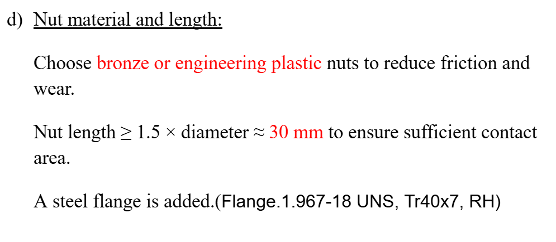

1. 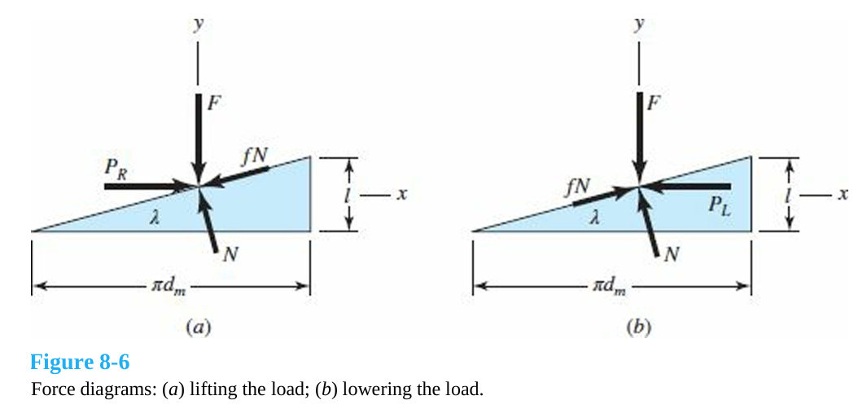We use equilibrium equations in x and y directions, **solving for *PR* and *PL***:

Where PR is the force to lift the load (defined as the force that makes the cradle to rotate clockwise to convey the paper roll), and PL is the force to lower the load.

Then, find the torque required by multiplying the load *P* with the mean radius *dm/2*,

$T_{R}=\frac{Fd_{m}}{2}(\frac{l+πfd_{m}}{πd_{m}-fl})$ $T_{L}=\frac{Fd_{m}}{2}(\frac{πfd_{m}-l}{πd_{m}+fl})$

1. **Thread failure:**

We use the von Mises theory to analyze thread failure:

1. Stress element:

$σ_{x}=σ_{b}$ $τ_{xy}=0$

$σ_{y}=σ$ $τ_{yz}=τ$

$σ_{z}=0$ $τ_{zx}=τ_{zx}$

1. Stress and Strain Components:

The nominal shear stress τ in torsion is

$τ=\frac{16T}{πd_{r}^{3}}$

The axial nominal normal stress σ is

$σ=-\frac{4F}{πd_{r}^{2}}$

Where,

$d_{r}= minor diameter=d-p$, *d* is the major diameter

The thread-root bending stress *σb* is

$σ_{b}=\frac{6F}{πd_{r}n_{t}p}$

Where *nt* is the number of engaged threads.

The tangential shear stress *τzx* is

$τ_{zx}=-\frac{4T}{πd_{r}^{2}n_{t}p}$

1. Three-dimensional von Mises stress:
$σ'=\frac{1}{\sqrt{2}}{[{(σ_{x}-σ_{y})}^{2}+{(σ_{y}-σ_{z})}^{2}+{(σ_{z}-σ_{x})}^{2}+6(τ_{xy}^{2}+τ_{yz}^{2}+τ_{zx}^{2})]}^{\frac{1}{2}}$

2. Compare against the yield strength of the material

$σ'=\frac{S_{y}}{n}$

Where *n* is the factor of safety and $n≈2.68>2.0$

1. **Recommended Commercial Part**

Lead Screw

| Size(mm) | Tr40x7 |
| --- | --- |
| Length(m) | 1 |
| Material | AISI 1018 Carbon Steel |
| Yield Strength(MPa) | 300 |
| Vendor | Roton |
| Price(usd) | $174.30 |

Nut

| Size(mm) | Tr40x7 |
| --- | --- |
| Material | Bronze |
| Vendor | Roton |
| Price(usd) | $137.71 |

[**40 X 7 Right Hand Trapezoidal Lead Screws & Nuts for Power Transmission - Roton Products, Inc.**](https://www.roton.com/family/trapezoidal-right-screws-and-nuts-7060882/)

[**Power Screw Analysis.ipynb**](https://colab.research.google.com/drive/12VaEfzcBI957ljxYqvTidNJCQ27JQOy3?usp=sharing)